Ideation Phase
Define the Problem Statements

Date | 06 July 2026
Team ID
Project Name | Online Complaint Registration System
Maximum Marks | 2 Marks

Customer Problem Statement Template:
A Customer Problem Statement helps to understand the challenges faced by users and identify their actual needs. It focuses on the user's difficulties and provides a clear direction for designing an effective solution.
The Online Complaint Registration System focuses on solving issues related to traditional complaint handling methods by providing a digital platform for complaint registration, tracking, and management.

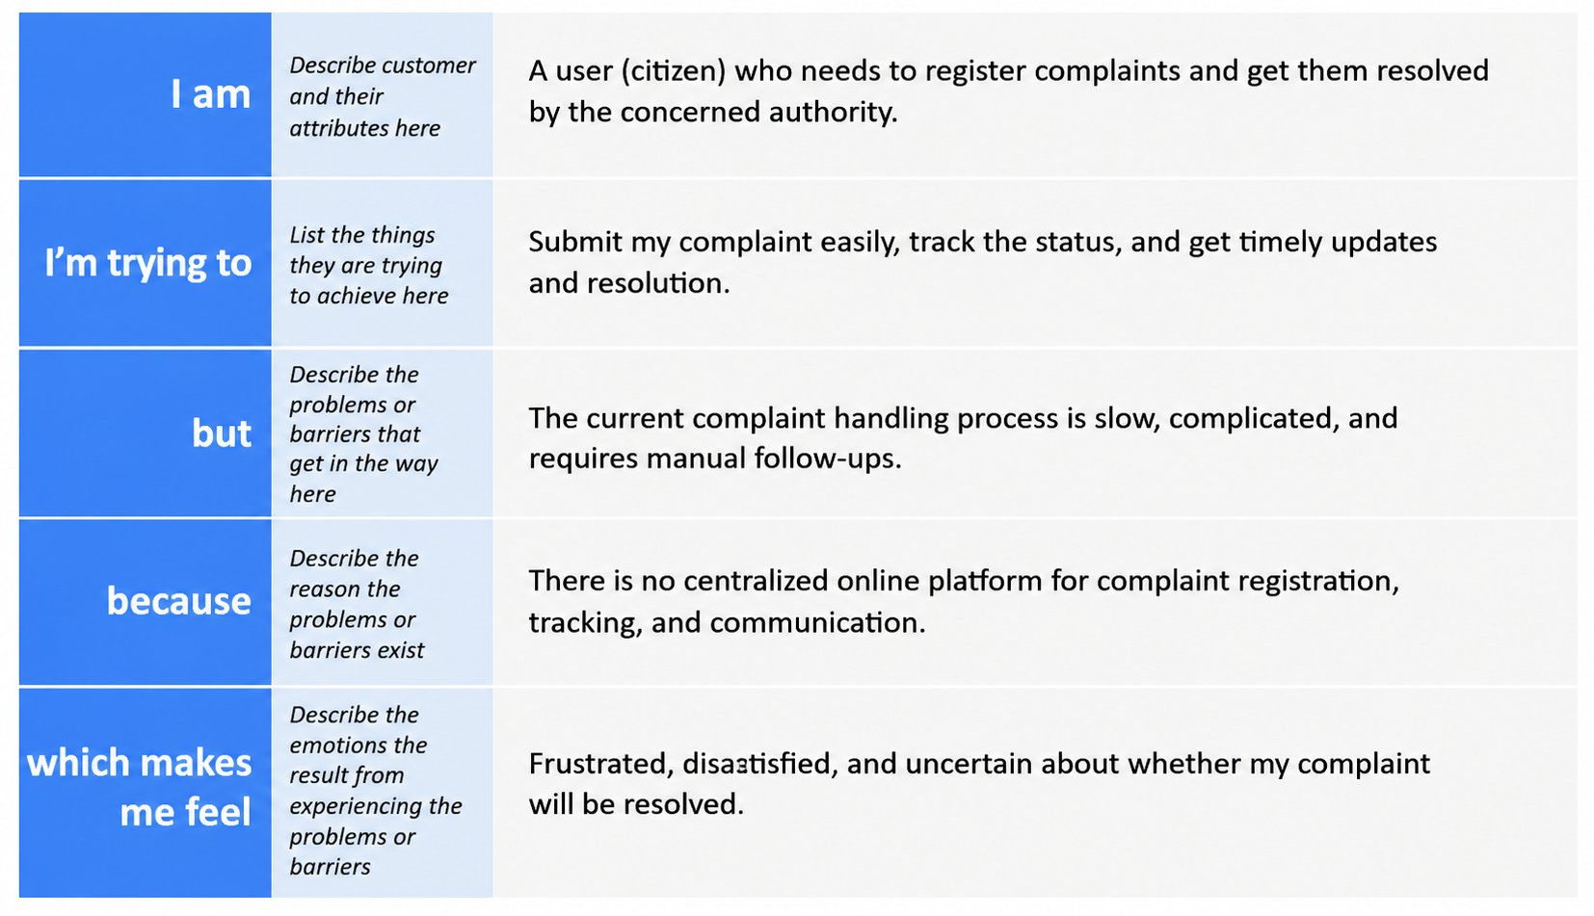Example:
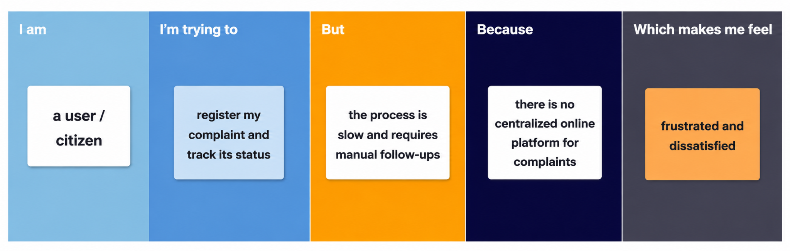

Problem Statement (PS) | I am (Customer) | I’m trying to | But | Because | Which makes me feel
PS-1 | User | Register my complaint easily | Manual process takes more time | No online complaint submission platform | Frustrated due to delays
PS-2 | User | Track my complaint status | Updates are not available quickly | Lack of proper tracking system | Unsure about complaint progress
PS-3 | Agent | Resolve user complaints effectively | Complaint information is difficult to manage | No centralized complaint database | Difficulty handling requests
PS-4 | Administrator | Manage complaints and users | Manual monitoring is inefficient | Lack of automated management system | Challenged in maintaining workflow

Reference: https://miro.com/templates/customer-problem-statement/

